Heather Lamb
CECS 6512
Spring 2014

Do certain types of online participatory activities
affect students’ perceptions of course quality?

Abstract
Seeking to understand the online learning, the authors attempt to understand whether or not certain types of online participatory activities affect students’ perceptions of course quality. Using a triangulation design, the author combined survey data collected as well as a semi-structured interview process to determine student perceptions about the types of participatory activities as they relate to online learning. Current students enrolled in LTEC and CECS students at a large, suburban higher education institution located in Southeastern United States volunteered to participate. The author specifically examined the types of participatory activities related to development of presence, community and the preferences of the online learner.

Table of Contents
Section A: Introduction
Section B: Literature Review
Section C: Methodology
Section D: Data Collection & Analysis
Section E: Conclusion

Introduction
With the increase in the numbers of students enrolled in online course as well as the number of higher education institutions who employ this type of learning environment, one has to wonder how an instructor can convert traditional classroom setting to virtual and ensure the learning outcome and student satisfaction at the same time. Previous, students relied on the physical classroom as a place to connect with other students, to engage in formal academic discourse, to participate in activities and to build a rapport with the instructor (Tinto, 1997). As a personally transformative experience, learning can facilitate solutions to complex problem (Ryman, Burrel, Hardman, Richardson & Ross, 2010). Researchers continue to seek out understandings as to how relationships between instructor behaviors and student participation are developed in the physical classroom (Ryman, et al., 2010). Now as the barriers of the classroom walls are removed, complex learning opportunities are still developed but are conflicted because of the distance.
When teacher and students are scattered around in different places and even different time zones, it is easy to create the potential for students to feel a lack of social connection with the teacher and other students. To combat this problem, online learning environments have to provide online learners with rich resources that promote flexible social interaction with the teacher and other students (Sung & Mayer, 2012). An important concept that has been explored in relation to social interaction in online learning environment is social presence. Social presence is the degree to which a person is perceived as “real” in mediated communication (Gunawardena & Zittle, 1997; Tu, 2002; Yen & Tu, 2011). In other words, social presence is referring to how participants feel they are interacting and connecting with real human when they are in online learning environment. There are numerous researchers recognize social presence as one of the most important aspects of online learning and a key to motivate learner’s efforts to learn as well as promoting their satisfaction with online course (Sung & Mayer, 2012; Cobb, 2009). Because the online learning is usually text-based and occurs in temporal and spatial isolation, it may be particularly susceptible to experiencing a lack of social presence. Therefore, it is very important for teacher or instructional designer to employ appropriate participatory activities with different technological tools to build up sense of learning community.
Establishing learning communities early in online education helps bridge distance and differences between physical and virtual worlds of teaching and learning (Baghdadi, 2011). Providing for a supportive community, an instructor seeks to create participatory activities that establish trust between students within the situation of the learning. This includes acceptance of beliefs and constructive discourse when viewed as a process of gaining new knowledge and perspectives (Johnson & Johnson, 2009). The instructor understands how to nurture the conversation while assessing the relevancy of the participatory activities (Ryman et al., 2010) This includes providing acceptable participatory activities that do not alienate a learner but establish a sense of belonging and encourages the authenticity of community development.
There is an expectation of the level of participation among students and instructors in an online learning environment relative to the relevancy of the types and styles of these activities which encourage the level of sharing, discussing and peer interaction (Lin & Tsai, 2012). As student engage in mutual exchange of information (Lave & Wenger, 1991), participatory activities invite behavioral and cognitive engagement (Lin & Tsai, 2012), which may provide opportunities for learners to engage in constructivist style of inquiry. This type of learning facilitates the development of high-order learning and information data mining (Lin & Tsai, 2012) thus leading to collective ideas and deeper communicative activities. The purpose of this mixed method study is to investigate the learner’s perception of current participatory activities in an online higher education environment and identify the factors of learners’ personal preferences that impact their behavior of participating online learning activities. From a theoretical standpoint using grounded theory (Creswell and Clark, 2011) this mixed methods study incorporates a combination of both quantitative and qualitative approaches while providing the framework to guide the nature of the following research questions:
Q1: How do participatory activities influence a student's sense of community?
Q2: How do students enrolled in online courses describe the interaction of student to student or student to instructor?
Q3: How does a student's personal learning preferences support advocacy of participation?
Significance of the Study
This study may provide significant contributions to the research related to student perceptions related to course quality. Instructional designers would benefit from the knowledge and understanding of the factors affecting student perceptions related to the types of online participatory activities which encourage a level of community, the social presence of the community and the learning preferences which support the types and styles of participatory activities in online learning.
Limitations
- This study will be confined only to currently enrolled students in the University of North Texas learning technologies or information sciences course of the Spring 2014 semester.
- Participant responses will only refer to their own personal reflections of online learning and not reflective of their current course.
- Due to the time factor and lack of available resources, the researcher may not have the ability to include other students who have participated in online learning courses for the first phase of the study, the quantitative portion and may skew this data.
Literature Review
Learning online… anywhere and anytime. As higher education institutions continue to compete for more students with less time, space, faculty and resources, the planning and creativity to capture the essence of online courses is a question that might be encountered along the way. Not only must online learning promote an environment of flexibility with social interactions, learners must be motivated by the richness of the resources, participatory activities, and construction of meaningful communication exchanges (Keengwe, Adjei-Boateng, & Diteeyont, 2013; Kang, & Im, 2013; Sung & Mayer, 2012). Allen and Seaman (2011) reported in a 2011 study, that during the fall of 2010, over 6.1 million students were taking at least one online course. As more and more students utilize this type of course approach, we must continue to develop an understanding the level of interactions which motivate and stimulate learners (Keengwe, Adjei-Boateng & Diteeyont, 2012) and elements which enable the type of conversations and increase the types of presence necessary to feel confident in the acquisition of new skills and knowledge (Kang & Im, 2013).
Social presence has been considered highly important while students are constructing common values and critical discourse due to the ability for learners to share ideas, sustain mutually acceptable and purposeful communication within the context of virtual environment (Garrison, Anderson, & Archer, 2010).
When media is used to communicate a specific purpose, the level of social presence has been determined to be a key factor in the effectiveness of interaction and student satisfaction (Ko, 2012). According to social presence theory, Short, Williams & Christi (1976 p.68), first developed the idea to “explain the impacts of communication medium on the way people communicate and interact”. Tu and McIsaac (2002) and Ko (2012) examined social presence in computer-mediated communications (CMC) and found that students who had familiarity with other students, a level of trust and positive attitudes towards technology developed a more positive perception. More recent studies show that students who actively engage in contributing, develop collaborative strategies and promote the idea of a community feel more socially connected and ready and willing to share (Peck, 2012). Students who fully engage in online learning, specifically student thought leaders, have been noted to inspire a richer conversation and a greater power to invoke strong contributions to the discussion (Waters, 2012). This also appears to be an influence on being socially connected. How students perceive themselves as being “socially connected” shows to be an indicator of productive interactions (Waters, 2012 p.347), but at the same time, an unintended consequence of online learning can easily force a student into isolation without effective facilitation and shared knowledge building by the instructor (Keengwe, Adjei-Boateng & Diteeyont, 2012). Participatory activities which support learner-centered interactions, the quality of the activities and the tools which promote engagement indicate a successful community in which students connect and engage to achieve collective learning outcomes (Keengwe, Adjei-Boateng & Diteeyont, 2012). Social presence indicates a level of communication cues whether or not formal or informal, the basic definition of social presence is filled with vagueness (Lyons, Reysen, Pierce, 2011). “Social presence is related to the subjective perception of feeling psychologically connected with others while engaging in social interactions through various mediums” (Lyons, et al., 2012 p. 182). The perceived level of connectedness has been positively linked with a students’ perceived satisfaction in online learning and thus additional research is recommended to understand how the informal and formal levels of communication, the types of technology used and media rich tools utilized affect ones social presence (Lyons, et al., 2012 p. 185). The instructor’s focus related to social presence is one that creates a learning environment that provides for student engagement that is commonly seen as self-directed and reflective (Ekmekci, 2013).

Methodology
Research Design
The purpose of this study is to investigate the learner’s perception of current participatory activities in an online higher education environment. Furthermore, sub-questions related to this research question will seek to identify the factors of learners’ personal preferences that impact their behavior of participating online learning activities. A triangulation design will be utilized to conduct this study and will involve a two-part data collection design. This approach to mixed methods is one of the most common methods whereas quantitative and qualitative data is used to analyze a single topic with merged results are reported into an overall interpretation (Creswell & Clark, 2011).
In quantitative research, a researcher will use a postpositivist view in which claims which are developed through numeric measurements (Creswell, 2014). This process is based on a process making claims based on a specific theory, while the researcher shapes his knowledge through data, evidence and measures recorded by the researcher (Creswell, 2014).
A researcher will use a data collection through to determine the degree of association between two or more variables as well as determine the frequency of relationships (Creswell & Clark, 2011; Creswell, 2014).
Through a level of inquiry, as an alternative, in qualitative research the researcher explores and understands the meaning of individuals or groups through inductively interpreting themes, analyzes data collected through a holistic picture and in the participants natural setting (Creswell, 2014). Qualitative researchers will examine documents, observe behaviors and often times utilize interviews (Creswell, 2014).
Combining both quantitative and qualitative, this study incorporates a mixed methods approach, originating around the late 1980’s, which of the strength of drawing from both quantitative and qualitative research, thus minimizing the limitations of both approaches (Creswell, 2014). By utilizing this approach, the researchers are provided different but important types of information.
Purposeful sampling procedures in which the researchers intentionally select the individuals to understand the central phenomenon will be utilized (Creswell & Clark, 2011). A limitation to this particular study is the limited time for collecting data and interpretation, which Clark and Creswell indicate as a reason to choose this particular research design (2011). Part one of this study will involve the collection of quantitative data through the survey instrument facilitated through Qualtrics. Research questions included in this survey instrument not only provide the researchers specific demographic data, but specific questions related to online learning have been included to support the purpose of this study and will further be used to evaluate respondents answers to determine interviewees as part two of the study. A follow up simple analysis of this survey data will serve to allow for selection of participants who will participate in the qualitative piece of the study. A semi-structured interview process will allow for researchers to access respondents through a telephone interview and ask a series of sub-questions related to the purpose and further understand:
Q1: How do participatory activities influence a student's sense of community?
Q2: How do students enrolled in online courses describe the interaction of student to student or student to instructor?
Q3: How does a student's personal learning preferences support advocacy of participation?
Target Population
The target population will be active students currently enrolled in either Learning Technologies or Library and Information Sciences at the University of North Texas Spring 2014 semester. To provide the researchers the confirmation of the age requirement of age 18 or older participants, respondents will agree to an initial statement of agreement upon entering into the online survey instrument. This initial selection will indicate whether or not the participant qualifies for this study and in turn validate the completion of the online instrument. Based on our submitted IRB, this protects both the survey respondents and the researchers.
Survey Instrument
An online survey will be distributed to students indicated in the target population. General questions related to specific demographics of the population include: gender, age, race; student status; experience with online learning; teaching experience. The remainder of the instrument relates to a variety of topics related to online learning, gamification and social media. For the purposes of this particular study, researchers will use the data related to online learning only. Data from the likert type question set of questions will be collected and analyzed for the second part of this study.
Data Collection procedures
The first, quantitative phase of the study will be used to determine interest and acceptance of availability of interviewing as well as being a viable candidate for the interview questions. The technique for collecting quantitative data is a self-developed questionnaire, containing a variety of multiple-choice questions using a likert scale. The second phase of the data collection will include a series of interview questions which will include sub-questions related to the major research question and online learning as it relates to participatory activities. This includes building community and social presence.
Data analysis will include reviewing of interview questions, coding specific information based on a series of categories, which match our current subset of questions and organization techniques. Statistical analysis will be conducted with the quantitative portion (part one) of this study.
Validity, Reliability, Transferability and Credibility
To ensure the validity and reliability of the data collected through the interview process, researchers will use 1) content validity provides that the different elements, skills and behaviors are adequately measured through the survey instrument and 2) internal validity through triangulation, member checking and peer examination (Zohrabi, 2013). For the purposes of this study, the survey instrument has been examined and samples examined and adjustments to the questions was facilitated.
Reliability of the data is an important piece of any research process (Zohrabi, 2013). The consistency, dependability and transferability of the research, as Lincoln and Guba point out, is better to not to attain the same results but rather to agree about the dependability and consistency of the data (1985).
Outcomes of the study will not be predicted, but rather allow for patterns and themes to emerge from the data as the collection and analysis is conducted. To conform to the transferability, rich details and explanations using thick descriptions will be utilized.
Data collection and analysis
There are three parts included in this section, part one is the demographics of survey, part two is the analysis about the online participatory survey questions, and part three is the interview result.
Part One: Participants
A review of the survey indicates the following: 46 participants started the survey; out of 46 participants, 5 did not finish; 3 were under 18 years old and 1 participant indicated that he/she did not wish to participate in this research study. 37 participants have completed the survey. The results of the descriptive statistics demonstrate that 25 (66%) of the participants were female and 13 (34%) were male. The age range was 43 with the youngest participants being 20 years old and the oldest one 63 years old. The average age of the participants was 37 years old. Reviewing the data, the largest of percentage of completed surveys indicates that the 20-25 age group with most participants under the age of 45, see Figure 1.

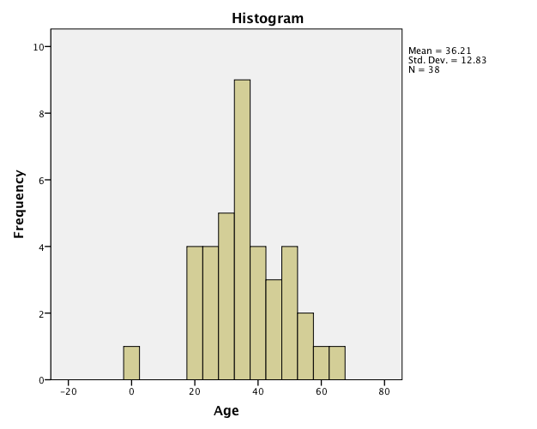
Figure 1 Age group
Further reviewing the data, 15 undergraduate students (41%) and 22 graduated students (69%). All of participants indicated that they have taken online courses, the maximum courses participant takes is 20, and the minimum is 3 courses, average is 9 courses. For current situation, 17 participants (46%) are taking fully online course, 22 participants (59%) are taking hybrid course and only 3 participants (8%) are taking pure face-to-face course this semester. Using IBM SPSS software, 18 questions related to online learning were evaluated for an validity which indicates an a=.694, within the range of ‘acceptable’ as noted by Devellis.

Part three: Survey Analysis
To further evaluate the specific questions as they relate to determining targeted interview questions, a factor analysis. An initial factor analysis was evaluated with data evaluated and forced into 3 factor groups (figure 3), based on the initial scree plot (Figure 2).
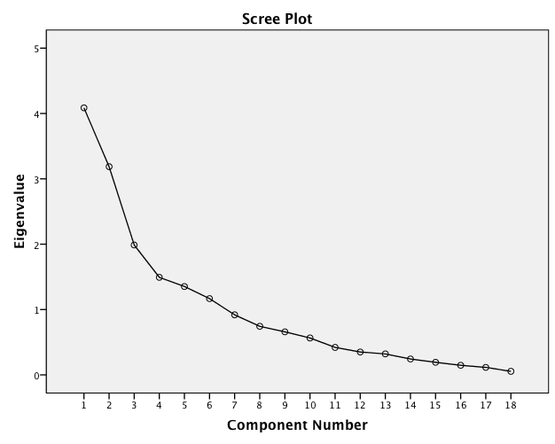
Figure 2

Rotated Component Matrixª
 | Component
 | 1 | 2 | 3
Online26_1 | -.022 | -.846 | .093
Online26_2 | .373 | -.147 | .466
Online26_3 | .278 | -.054 | .462
Online26_4 | .693 | -.007 | .404
Online26_5 | .004 | -.315 | .630
Online26_6 | .250 | -.106 | -.467
Online26_7 | .677 | .112 | .087
Online26_8 | .019 | .643 | -.028
Online26_9 | -.101 | .008 | -.551
Online26_10 | .546 | .323 | -.440
Online26_11 | .625 | .318 | -.096
Online26_12 | .807 | .028 | .020
Online26_13 | .801 | -.015 | -.017
Online26_14 | -.056 | .477 | .633
Online26_15 | .473 | -.144 | .374
Online26_16 | .081 | .875 | .095
Online26_17 | .470 | .502 | -.272
Online26_18 | .117 | .504 | -.471
Extraction Method: Principal Component Analysis.
Rotation Method: Varimax with Kaiser Normalization.
a. Rotation converged in 7 iterations.
Figure 3
Factor analysis was conducted as a data reduction tool to remove redundancy or duplication from the set of correlated variables with a smaller set of derived variables. Reviewing the questions from the survey, although the questions were relatively independent of one another. This was done to allow the researcher to describe many variables using a few factors. Using online learning as the main focus of this survey, the researchers were able to select a small group of variables representative of a larger set. The factor analysis allowed the researchers to look for patterns and reduce the number of variables to review. A hierarchal cluster was developed to understand and group questions into groups representing themes that were then used to develop interview questions.

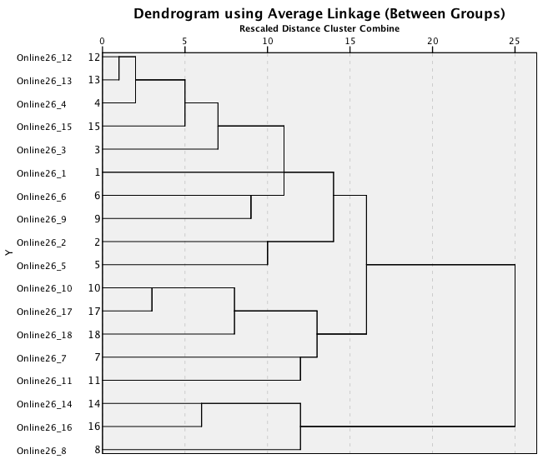
Figure 4
An analysis of the data, specifically looking at clusters or theme of possible interview questions. Upon further evaluation, the researchers found Q14/16/8 clustered together. Reviewing the context of these question, the relationship includes possible themes as follows:
Question 14/16/8 – Anxiety of the learner
Question 12/13/4 – Content
Question 10/17/18/7/11- Types of activities

Results from the data collection of a Qualtrics survey shows the following data points and the mean.
 | Question | Strongly Disagree | Disagree | Slightly Disagree | Slightly Agree | Agree | Strongly Agree | Total Responses | Mean
1 | Money spent on online courses are well worth spending | 1 | 2 | 3 | 6 | 15 | 11 | 38 | 4.71
2 | Video-based lectures are fun and interesting | 1 | 3 | 3 | 16 | 7 | 6 | 36 | 4.19
3 | Watching instructional videos for personal growth (i. e. youtube,TED Talks, etc) is engaging | 1 | 1 | 2 | 9 | 10 | 15 | 38 | 4.87
4 | Video Based Lectures are helpful | 1 | 0 | 2 | 16 | 12 | 7 | 38 | 4.55
5 | Asynchronous text-based environments are fun and interesting | 3 | 2 | 9 | 13 | 8 | 3 | 38 | 3.79
6 | Asynchronous text-based discussion forums are too time-consuming. | 0 | 2 | 7 | 13 | 10 | 6 | 38 | 4.29
7 | Audio/video-based lectures are more effective to my learning than text-based ones. | 1 | 6 | 5 | 10 | 8 | 7 | 37 | 4.05
8 | My learning is negatively impacted by the technical issues I encounter when participating in online activities | 5 | 9 | 5 | 10 | 4 | 5 | 38 | 3.37
9 | I prefer working individually than doing online collaborations in groups for assignments | 0 | 2 | 3 | 10 | 7 | 16 | 38 | 4.84
10 | I wish I could have more one-to-one interactions with the instructor. | 1 | 6 | 4 | 7 | 15 | 5 | 38 | 4.16
11 | A thorough student orientation to the learning management system is very important before taking an online course. | 1 | 4 | 4 | 9 | 6 | 13 | 37 | 4.46
12 | Well-organized course content and clear instructions about where to find them are very important to my learning. | 0 | 1 | 0 | 3 | 9 | 24 | 37 | 5.49
13 | Instructors should participate actively in online discussions. | 0 | 1 | 3 | 10 | 11 | 13 | 38 | 4.84
14 | We can learn more from our classmates than from the instructor in an online course. | 5 | 7 | 13 | 5 | 7 | 1 | 38 | 3.13
15 | Online communications with classmates and instructors are very important in my learning. | 2 | 2 | 3 | 6 | 15 | 10 | 38 | 4.58
16 | I am easily lost in an online course. | 10 | 10 | 7 | 7 | 4 | 0 | 38 | 2.61
17 | I much prefer face-to-face interactions in a class than online interactions. | 3 | 5 | 9 | 12 | 5 | 4 | 38 | 3.61
18 | Taking an online course is no different than teaching yourself. | 3 | 8 | 7 | 11 | 5 | 4 | 38 | 3.5

Figure 5
Part two: Semi-structure interview
In order to expand the deep of this research, there were two participants follow up interview conducted about two weeks after the survey. Each of them was around 20-30 minutes: one was conducted in face-to-face format, and another was conducted by telephone. This semi-structure interview questions were based on following:
- From your experience, how do you feel like the sense of community you build up between you and your instructor and your peers?
- What kind of interactive activities you feel like most helpful for you to build up the community?
- How do you think your personal preference affect your behavior to participate those activities?
There were two participants selected by the pool of survey participants, one was male (Eric) and another was female (Erin). Both of them are graduated students and in their last semester of master program, the average number of their online courses experience is 12 courses.
Part Four: Interview Analysis
The final part of the research includes an analysis of the interview. The semi-structured interview was transcribed and offered to be member checked. The data was compared through a peer debriefing to compare general themes as well as determine specific questions related to our sub-questions. Using a holistic coding process, general themes emerged which the research compiled into three areas. Area one was coded to explore the type of interactive activities (participatory). Erin indicated that she and her cohort self-directed by taking the activities and extending it by pre-meetings and connecting through Skype, etc. Eric indicated that the instructor encouraged the use of video during their webconference sessions. Eric indicated that this type of activity supported his sense of community and allowed for a feeling of presence. Both students shared indicators and examples of the application of the types of activities including peer feedback, offline discourse (not through discussion boards) and the ability to feel “more connected”. The final theme which emerged through the coding process includes the impact of the activities. Both students indicated a feeling of satisfaction and completion that they attributed to the activities encouraged by the instructor. In general, both interview participants shared positives attitude about their online courses experience and they both feel they have a stronger of sense of community building up through the activities of the course. Specific examples of the response to support these themes include:
“ I actually surprise that how much positive experience I have in the program” (Eric)
For what kind of participatory activities help them build up the sense of community, both interview participants mentioned web conference (Adobe Connect) during the interview. Because web conference provides them a synchronous environment to communicate with their peers.
“The most successful and make me felt most connected with peers was when we got into the Adobe Connect, and like more than five of four people were using video” (Eric)
“I like that my professor uses Adobe Connect, it formalized the sessions.” (Erin)
Second, cohort also helps interview participants to build up the community in online learning environment, because they have the same class with at least some of the same students, so it was easier to build up the connection with the same group of students after they knowing more about each other.
“We work in cohort and there are certain amounts of time, 2 or 3 people in same class, you can get into collaborative groups and work collaboration – in groups on a paper – for peer reviewing, helps with community building.” (Erin)
“……be in kind of cohort, really helps, because you kind of working with the same people, and you get to know them…you don’t build community with everybody, but I would say that there are several students I have community with” (Eric)
Third, peer review/feedback is another interactive activity can assist student to develop their community sense.
“…...like peer review and peer feedback, we do that……I do think those things getting interactive with each other works is helps to build the sense of community…… When we have big projects/ feedback - not only from the professor, but good feedback from each other, it helps with the community building, writing and reviewing with peers.” (Eric)
“I like peer reviews, you get to comment and opportunities to look at peers works and review. “ (Erin)
Fourth, both interview participants were talking about interactive activities happened outside the classroom environment would help online learning students to build connection with other students or instructor, such as informal chatting with social media (Twitter), Google Hangout, phone commutation, virtual environment such as Second Life, social event or even early chatting before Adobe Connect class start.
“We used to get into the adobe connect early, —and have informal chats and connect with the other classmates to find out things about them. I like this and felt more connected.” (Erin)
“Having that outside classroom experience that also help (build the sense of community)……you get to talk to your partner in Second Life, that is kind of cool…our peer students can talk in different environment……the space was very nature feeling” (Eric)
On the other hand, there are some difficulties for interview participants when they build up their sense of community by participatory activities, such as discussion board.
“When I first started the online courses, it was hard to development the sense of community……I found that discussion board were like forced discussions” (Erin)
“I like discussion board, the only issue of that we several have discussed of that is just so easy to do minimum……because everybody is so busy…….So if there is way to be more interactive that way, that might be more beneficial“ (Eric)
Using Both interview participants indicated that their personal preference do affect their behavior when they engage in the participatory activities. Eric talked about different working pace really affect him when he worked with others in discussion board, and Erin mentioned that she is a social person, she likes to work in groups.
Conclusion
To understand whether or not certain types of participatory activities affect students’ perception of course quality, a mixed methods approach was utilized. In an attempt to further understand this major question, three sub-questions were created. Presence, community and the learning preferences or styles of the learner were evaluated to better understand how these topics relate to the students overall perception of the online courses.
The initial survey responses indicated that all participating students did have experience with online learning. Focusing on a series of 18 questions related to online learning, several themes emerged which allowed the researchers to delve deeper into several themes of questions and whether or not these related to the specific sub-questions the authors were seeking to understand. To further the development of this research, two students were selected to engage in semi-structured interviews. “Erin” & “Eric” demonstrated a shared belief that community was an important factor to their own personal approach to online learning as well as how successful they feel in the course. The two interviewees both indicated positive results in online learning, but found that much of their own success was related to the types of activities, but specifically when understanding the question related to ‘community’, both Eric & Eric shared the types of activities which promoted an environment of acceptance. Using a variety of types of online learning, Eric & Erin shared specific examples including virtual connections, video broadcasting and visual boards which encouraged to connect prior to class time and outside of class time. Eric indicated that although the barrier of distance could have prevented or interfered with learning or discussions, both students took it upon themselves to involve themselves in discussions. Although the students never met face to face, the instructor encouraged these type of connections to bridge the gap of distance. This supports our question related to community. Both of these students were successful, not because of the specific activity, by the activity encouraged students to participate in sometimes non-conventional ways and many times self-directed, thereby building a sense of community which transferred into a positive online experience.
Another factor related to the emerging themes was learning preferences of each student. Both Erin and Eric indicated through their own participation, they felt that student-to-student feedback was extremely valuable and the natural style of the conversation increased the positive experience in online courses. Both students also indicated that they were encouraged by the professors to engage in these exchanges.
The final question related presence and how the activities encouraged discourse and higher exchanges among the online learning. The students indicated that although they felt this was important, it was not something that they felt was promoted through the activities, but by the students themselves. Eric indicated that although he would like to have deeper discourse, he also wanted to complete tasks and sometimes did this before anyone else had started. Erin also indicated a frustration in waiting for others and would independently seek out other classmates to dialogue or connect with.
This research supports the initial question as to online participatory activities, but further research should define the topic of “course quality” and how or why this is an important topic related to online learning. As more and more students utilize this type of learning, it is even more apparent the need to better understand not only how to design courses that meet the needs of the learner, but the type of activities which further promote the idea of community.

References
Baghdadi, Z. D. (2011). Learning community in online education. Turkish Online Journal of Distance Education, 12(4), 12-16.
Creswell, J. (2014). Research Design. Thousand Oaks, CA: Sage.
Lave, J., & Wenger, E. (1991). Situated learning: Legitimate peripheral participation. Cambridge: Cambridge University Press.
Ekmekci, O. (2013). Being there: Establishing instructor presence in an online learning environment. Higher Education Studies, 3(1), 29-38.
Garrison, D. R., Anderson, T., & Archer, W. (2001). Critical thinking, cognitive presence, and computer conferencing in distance education. American Journal of Distance Education, 15(1), 7–23.
Garrison, D. R., Anderson, T., & Archer, W. (2010). The first decade of the community of inquiry framework: A retrospective. The Internet and Higher Education, 13(1–2), 5–9.
Kang, M., & Im, T. (2013). Factors of learner–instructor interaction, which predict perceived learning outcomes in online learning environment. Journal of Computer Assisted Learning, 29(3), 292-301.
Keengwe, J., Adjei-Boateng, E., & Diteeyont, W. (2013). Facilitating active social presence and meaningful interactions in online learning. Education and Information Technologies, 18(4), 597-607.
Ko, C. (2012). A case study of language learners' social presence in synchronous CMC. ReCALL : The Journal of EUROCALL, 24(1), 66-84.
Lin, C., & Tsai, C. (2012). Participatory learning through behavioral and cognitive engagements in an online collective information searching activity. International Journal of computer-supported collaborative learning, 7(4), 543-566. doi:10.1007/s11412-012-9160-1
Lincoln, Y. S. & Guba, E. G. (1985). Naturalistic inquiry. Thousand Oaks, Calif.: Sage.
Lyons, A., Reysen, S., & Pierce, L. (2012). Video lecture format, student technological efficacy, and social presence in online courses. Computers in Human Behavior, 28(1), 181-186.
Oliver, R., & Herrington, J. (2000). Using situated learning as a design strategy for web-based learning. In B. Abbey (Ed.), Instructional and cognitive impacts of Web-based education (pp. 178-191). Hershey, PA: Idea Group.
Peck, J. J. (2012). Keeping it social: Engaging students online and in class. Asian Social Science, 8(14), 81-90.
Ryman, S., Burrell, L., Hardham, G., Richardson, B., & Ross, J. (2010). Creating and sustaining online learning communities: Designing for transformative learning. International Journal of Pedagogies and Learning, 5(3), 32-45.
Short, J., Williams, E, & Christie, B. (1976). The social psychology of telecommuncations. London: John

Wiley & Sons.
Sung, E., & Mayer, R. E. (2012). Five facets of social presence in online distance education. Computers in Human Behavior, 28(5), 1738. doi:10.1016/j.chb.2012.04.014
Tinto, V. (1997). Classrooms as communities—exploring the educational character of student persistence. Journal of Higher Education, 68(6), 599−623.
Tu, C. (2000). On-line learning migration: From social learning theory to social presence theory in a CMC environment. Journal of Network and Computer Applications, 23(1), 27-37.
Tu, C. H., & McIssac, M.. (2002). The relationship of social presence and interaction in online classes. The American journal of distance education, 16(3), 131-150.
Waters, J. (2012). Thought-leaders in asynchronous online learning environments. Journal of Asynchronous Learning Networks, 16(1), 19.
Zohrabi, M. (2013). Mixed method research: Instruments, validity, reliability and reporting findings. Theory and Practice in Language Studies, 3(2), 254.

